ENAE 380 Project Design Documentation

Simulating NBA Seasons - William Rowe

1.1 Introduction

My project is a set of python programs that scrapes data from an online database, parses it into a data frame, and uses machine learning to simulate previous NBA seasons (specifically the 2018 season through the 2021 season). The script simulates and displays win totals for each team compared to actual win totals in a given season, the simulated seedings in each conference (including the teams respective wins count and SRS score), text showing the results of simulated play-in tournaments and playoffs, a bracket of the simulated playoffs, and the real playoff bracket from that year. I chose this as my project because I am a big fan of the NBA league, and I thought that it would be interesting to use my knowledge and passion of the league to challenge me to create a way to simulate how recent NBA seasons could have otherwise panned out.

The way NBA seasons work is that there are two conferences. One is the eastern, and one is the western. Both are composed of 15 teams within their respective region of the U.S. Each team plays 82 games during the regular season (barring the 2021 season where teams only played 72 due to the pandemic), and at the end of the season. Each conference ranks their teams 1 through 15 based on their total wins during the regular season. These rankings are also known as seedings.

Up until 2020, teams would go straight into the playoffs, with each conference’s first seed playing the eighth seed, second seed playing the seventh seed, third seed playing the sixth seed, and fourth seed playing the fifth seed. The purpose of this order was to reward teams that played really well during the regular season by making them face off against much worse teams at the start of the playoffs. The order of team matchups can be seen with the empty bracket below:

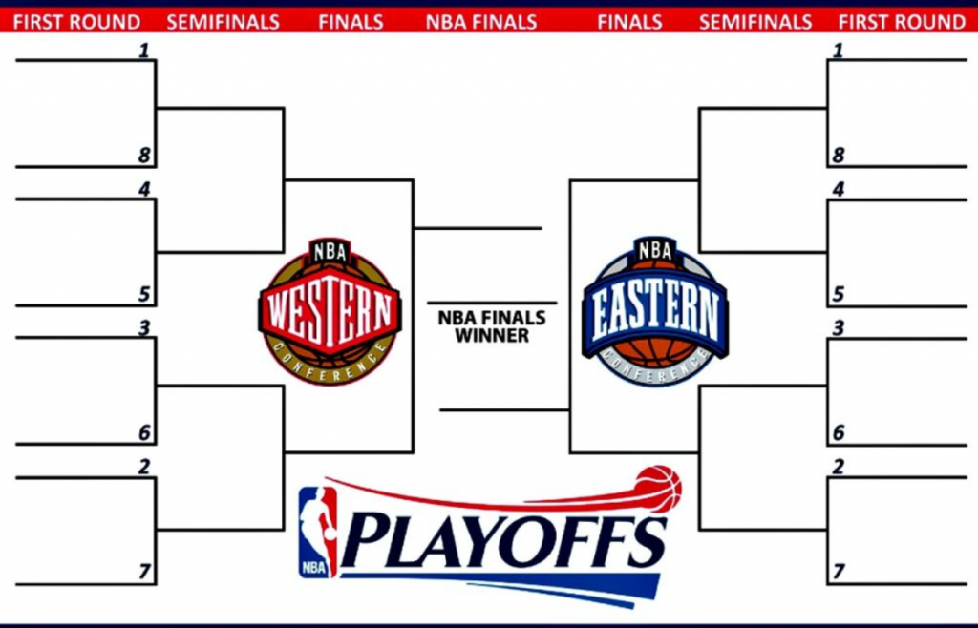

Fig. 1

After 2020, the matchups changed. A new concept called the play-in tournament was introduced where the seventh and eighth seed would compete for the seventh seed spot in the playoffs, and the loser would compete with the winner of a game between the ninth and tenth seed for the eighth seed spot in the playoffs, as seen below:

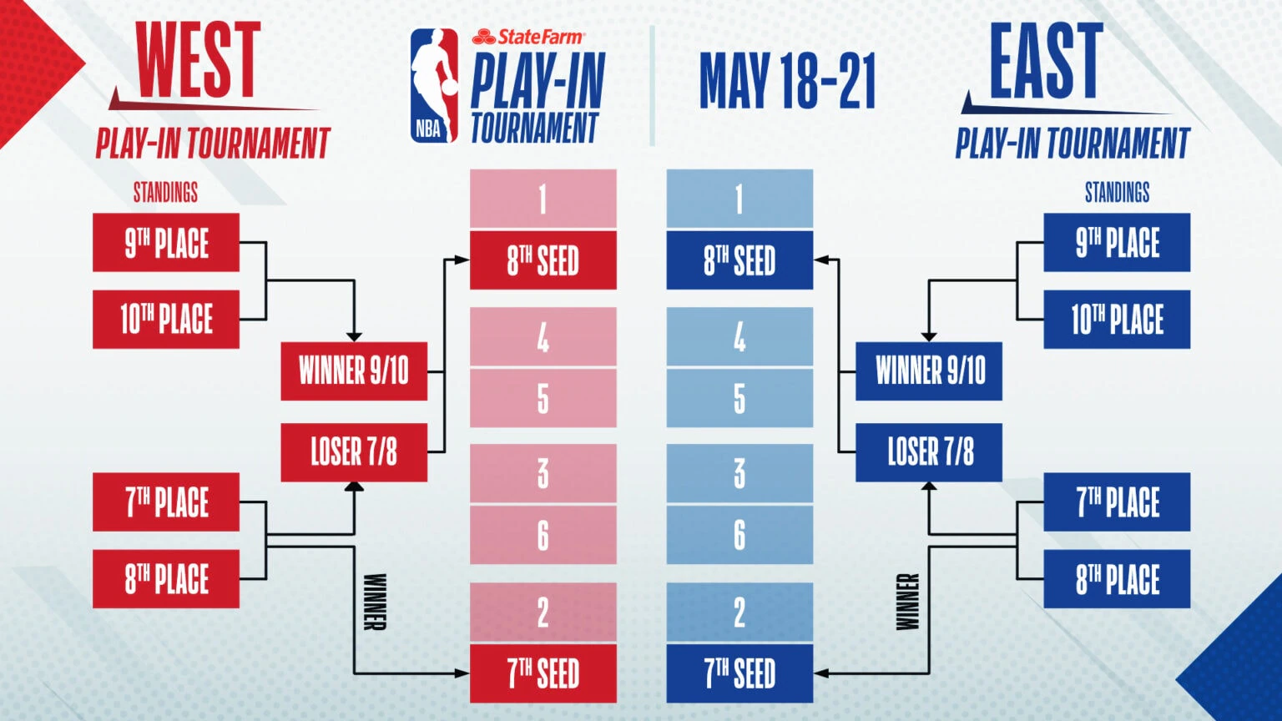

Fig.2

This playoff structure is what I would go on to implement when simulating the playoffs of seasons based off of each team’s SRS score (which is a rating system which takes a teams points per game, opponent points per game, strength of schedule, etc. and assigns a positive or negative integer score based on those statistics).

In order to simulate the regular season to drive team wins, I had to do some research. I ended up coming across two videos from a YouTube channel called Dataquest. He showcased code and explained [scraping data from websites and turning that data into a clean and neat data frame](https://youtu.be/o6Ih934hADU) to then analyze. He introduced and showed [how to simulate a team's wins over the course of games and seasons](https://youtu.be/egTylm6C2is) based on past seasons data from the data frame. For instance, because the first season we downloaded was 2016, the first season we can simulate is the 2018 season, because the function to simulate a season first analyzes the previous two seasons and makes a prediction on if the team wins the next games or not. Afterwards, it uses the past three seasons to simulate the 2019 season, etc.

Predicting the outcome of the next game in sequence is accomplished by selecting the best features/stats that go into determining the outcome of a game and using cross validation to train the model using those past stats to simulate subsequent data.

1.2 Design Process

Once I had this foundation of machine learning from a data frame, I was able to get started on my own code specific to the goals of this project. I made two for loops, one simulating the wins over the course of the listed seasons for each of the eastern teams, and another simulating the wins over the course of the listed seasons for each of the western teams. I made additions to the for loops that would change the outputs.

For instance, I took a segment of the predictions data frame (which showed real vs. predicted wins) that corresponded to the season the user inputted (as seen in Fig. 3). The segmented data frame listed 82 games (save 2021 which had 72 due to COVID-19). I took the sum of the “prediction” column to calculate the win total for the team the loop is simulating. After, the loop nears the end before going on to analyze the next team.

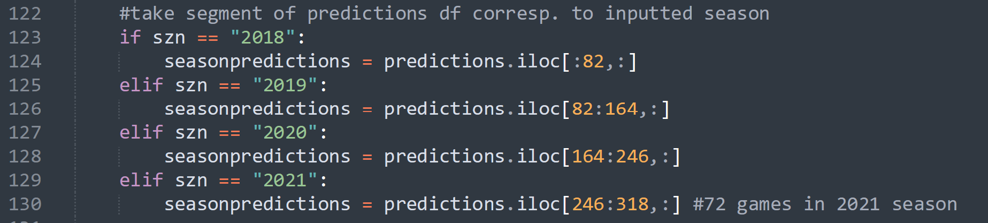

Fig. 3

First, it prints the segmented season predictions data frame, prints the team’s abbreviation name with their win total, and then prints a simple progress message displaying how many teams have been analyzed out of all 30 teams in the league.

Then, I made a series of if-else statements and while loops to sort lists that included the teams from highest wins/seed to lowest wins/seed, the actual win totals highest to lowest, and teams’ SRS scores respective to the order of the list of teams from highest win total/seed to lowest win total/seed. I organized the lists as such because it would make simulating playoffs and play-ins easier to keep track of later on since I know that the one seed’s info is the zero index in these lists, the second seed’s info is the one index, etc. Because this was embedded in the list of conference teams for loop, the lists were made twice, one for east and one for west. Lastly, I appended the analyzed team’s name abbreviation and their win total to empty lists which will eventually be used to plot simulated team win totals versus actual team win totals.

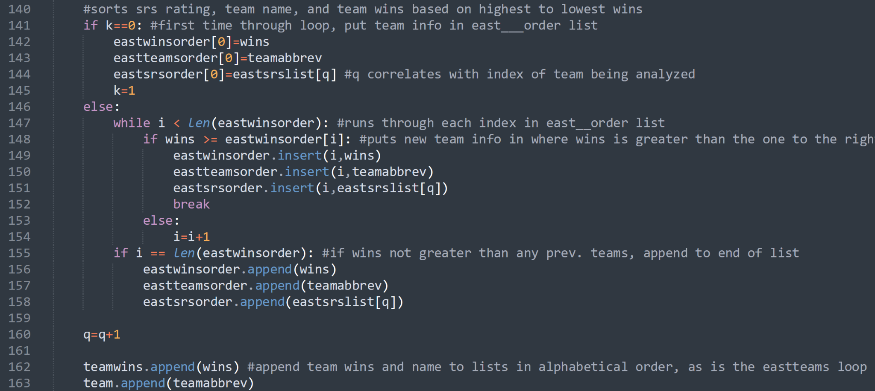

Fig. 4

Once this for loop was executed for the eastern conference and then the western conference, I printed the east and west lists of team seedings from highest to lowest, their win totals in the same order (so highest number of wins should be first index, descending from there), and the corresponding SRS rating with each index in the list pairing with the same index team and their win total.

I then plotted two bar graphs, one with the list of analyzed teams and their corresponding wins that were appended at the bottom of the for loops, and another below with the list of teams and their corresponding actual win totals for that season. This would help the user compare and see how the regular season results for that season could differ from or mirror one another.

I then simulated the east and west play-in if the season the user inputted to simulate was either 2020 or 2021. This can be seen in Fig. 5. As with everything else thus far, the west mirrors the east analysis, but with the west teams and team information. For the analysis of one of the eastern conference’s play-in tournaments, I appended the one to six seed to a new list called “eastteamsroundone” which will be used in the playoff simulation. I then compared the SRS of seed seven and eight to designate the new seven seed for the first round of the playoffs (as the six index in the “eastteamsroundone” list). I then compared the SRS of the loser of that matchup to the winner of the nine and ten seed matchup (which was determined based on who had a higher SRS) and the winner of that match is assigned the eight seed for round one of the playoffs by assigning their team values to the seven index in the “eastteamsroundone” list.

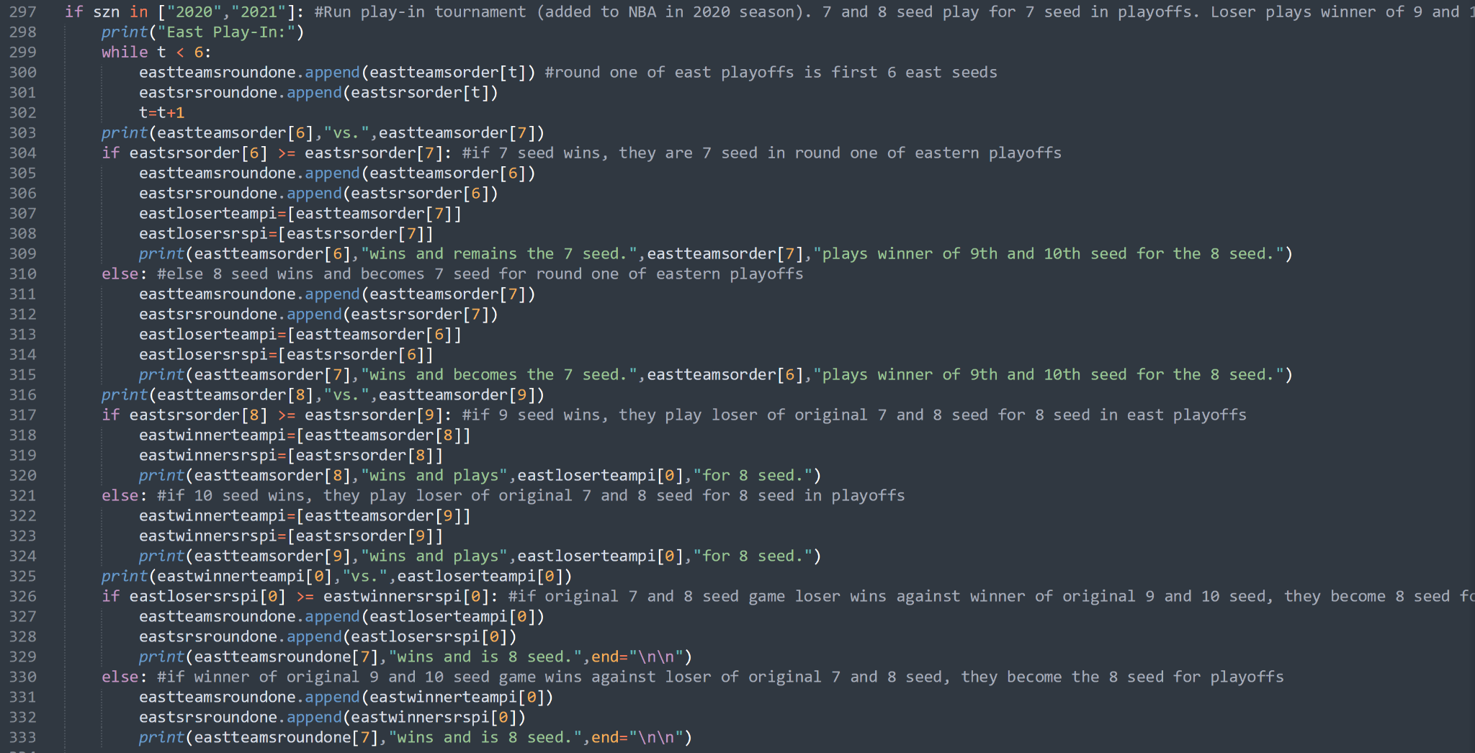

Fig. 5

If the user did not input 2020 or 2021, then the script would assign the order of east and west teams’ seedings to the “east/westteamsroundone” list respectively.

Once both east and west play-ins were run if needed, and all seedings for the playoffs were determined, I started to simulate playoffs. The general method is similar to how I coded the play-in to be simulated. I compared the team srs scores, and the higher seed won if their SRS was greater or equal to the lower seed’s, else the lower seed one, the winner would be appended to the next round list. You can see an example of how the round lists’ indexes work for simulating the eastern conference in Fig. 6 below.

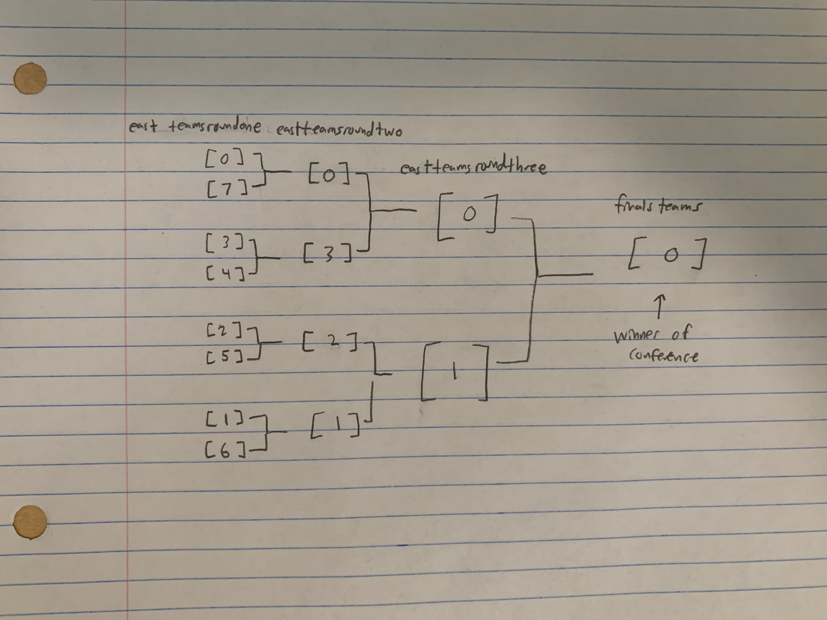

Fig. 6

For the west, the lists would just have west instead of east in the name, and the winner of the west would be appended to the one index of finals teams since the east was simulated first, thus the west winner is the second team added.

Then, the finals were determined by comparing the SRS values of both teams again. If both SRS ratings were equal, a random integer of one or two would be generated to determine who wins since both teams are essentially evenly matched. If the value is one, the east team would win and the west team would win if the integer was two. Each match up for the play-in and playoffs printed out who versed who and who won.

Now that the results of the postseason were created, I designed diagrams to visualize the relevant brackets associated with the season’s playoffs and potential play-in.

First, I made the script plot the play-in if needed so that the user could see who qualified for the seven and eight seeds in the playoffs. I created a pyplot figure with the axes covering all of the diagram save the top so that a title would fit. I then set the x and y scale to be proportional to the figure size such that the circles will not scale to be ellipses due to one axis being stretched compared to the other. I input center point coordinates on the plot for where team names would be placed to visualize a bracket shape. The winner of a given matchup would have their name advance and move toward the center of the screen horizontally and be placed in between the previous matchup vertically. I wrote what team name would pair with what center such that the matchups would be correct. Then, I drew a circle that would go around each center so that each team name was enclosed (making the diagram look more complete and easier to read). Finally, I added a title displaying that it was the simulated play-in tournament for either 2020 or 2021.

I then made the diagram for the simulated playoffs, which used the same principle, except included more centers so that the playoff bracket included all necessary teams and matchups. The final center in the middle of the diagram would display what team won the championship. The title then wrote that it was the simulated playoffs for the selected season.

Finally, a bracket of the actual playoff results from the given year was made which had team names differ depending on the year.

Initially with my project, I was planning on simulating much more past seasons and/or analyzing a user inputted team more in depth to display player stats for the team. As I started to go through with the project and do some more research, I quickly realized simulating much more past seasons would take far too long to run/set up, as it took over 30 hours straight to just gather data for the seasons’ games which I have now. Additionally, with player trades, injuries, roster updates, multiple different combinations of player matchups in game, etc., it would be far too complicated to try and get an idea of how a given player would accurately perform. That is when I shifted toward the idea of analyzing a desired season from 2018-2021 more in depth and simulating the postseason based on results of the regular season.

After coding the machine learning algorithm with the assistance of Dataquest, initially it was giving the same predictions result for each team, but after debugging, I found out it was a problem with a segment that helped make the predictions a little more accurate by analyzing team performance in the last ten games played. After trying to fix the problem numerous times, I was unable to fix the problem and just removed this part of the algorithm from my script so that I could continue on with my project and start working on my own code.

When I made my project, I took things one step at a time, and when I needed a new set of data I either created a list of it if it was real life data or made a way to calculate it if it was simulated data. The first instance was when I realized I required an organized list of teams from highest seed to lowest seed, I added the code in Fig. 4 to the loop so that that data could be created. Then, in order to compare the simulated win totals for each team in a given season to the real win totals, I had to create a list of win totals for each season with the indexes matching up with the list of team names. I then needed the team’s SRS scores for that season as well in order to simulate playoff matchups. This process can be seen in Fig. 7.

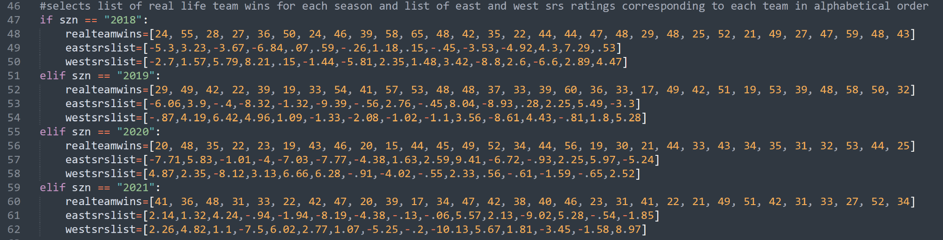

Fig. 7

In order to simulate the playoffs, I needed to make new lists composed of the teams that were competing. This is when I created empty lists to which teams who qualified for spots in the playoffs or won matchups for a spot would be added to.

1.3 Results

At the end of the coding process, all scripts equate to a total of roughly 763 lines of code. The file getdata.py, seen in Fig. 8, essentially scrapes data from basketball-reference.com month by month for each selected season, then scrapes each month’s data to derive the html files corresponding to each basketball game, containing stats and other relevant information such as the two teams that played and the data the game was played.

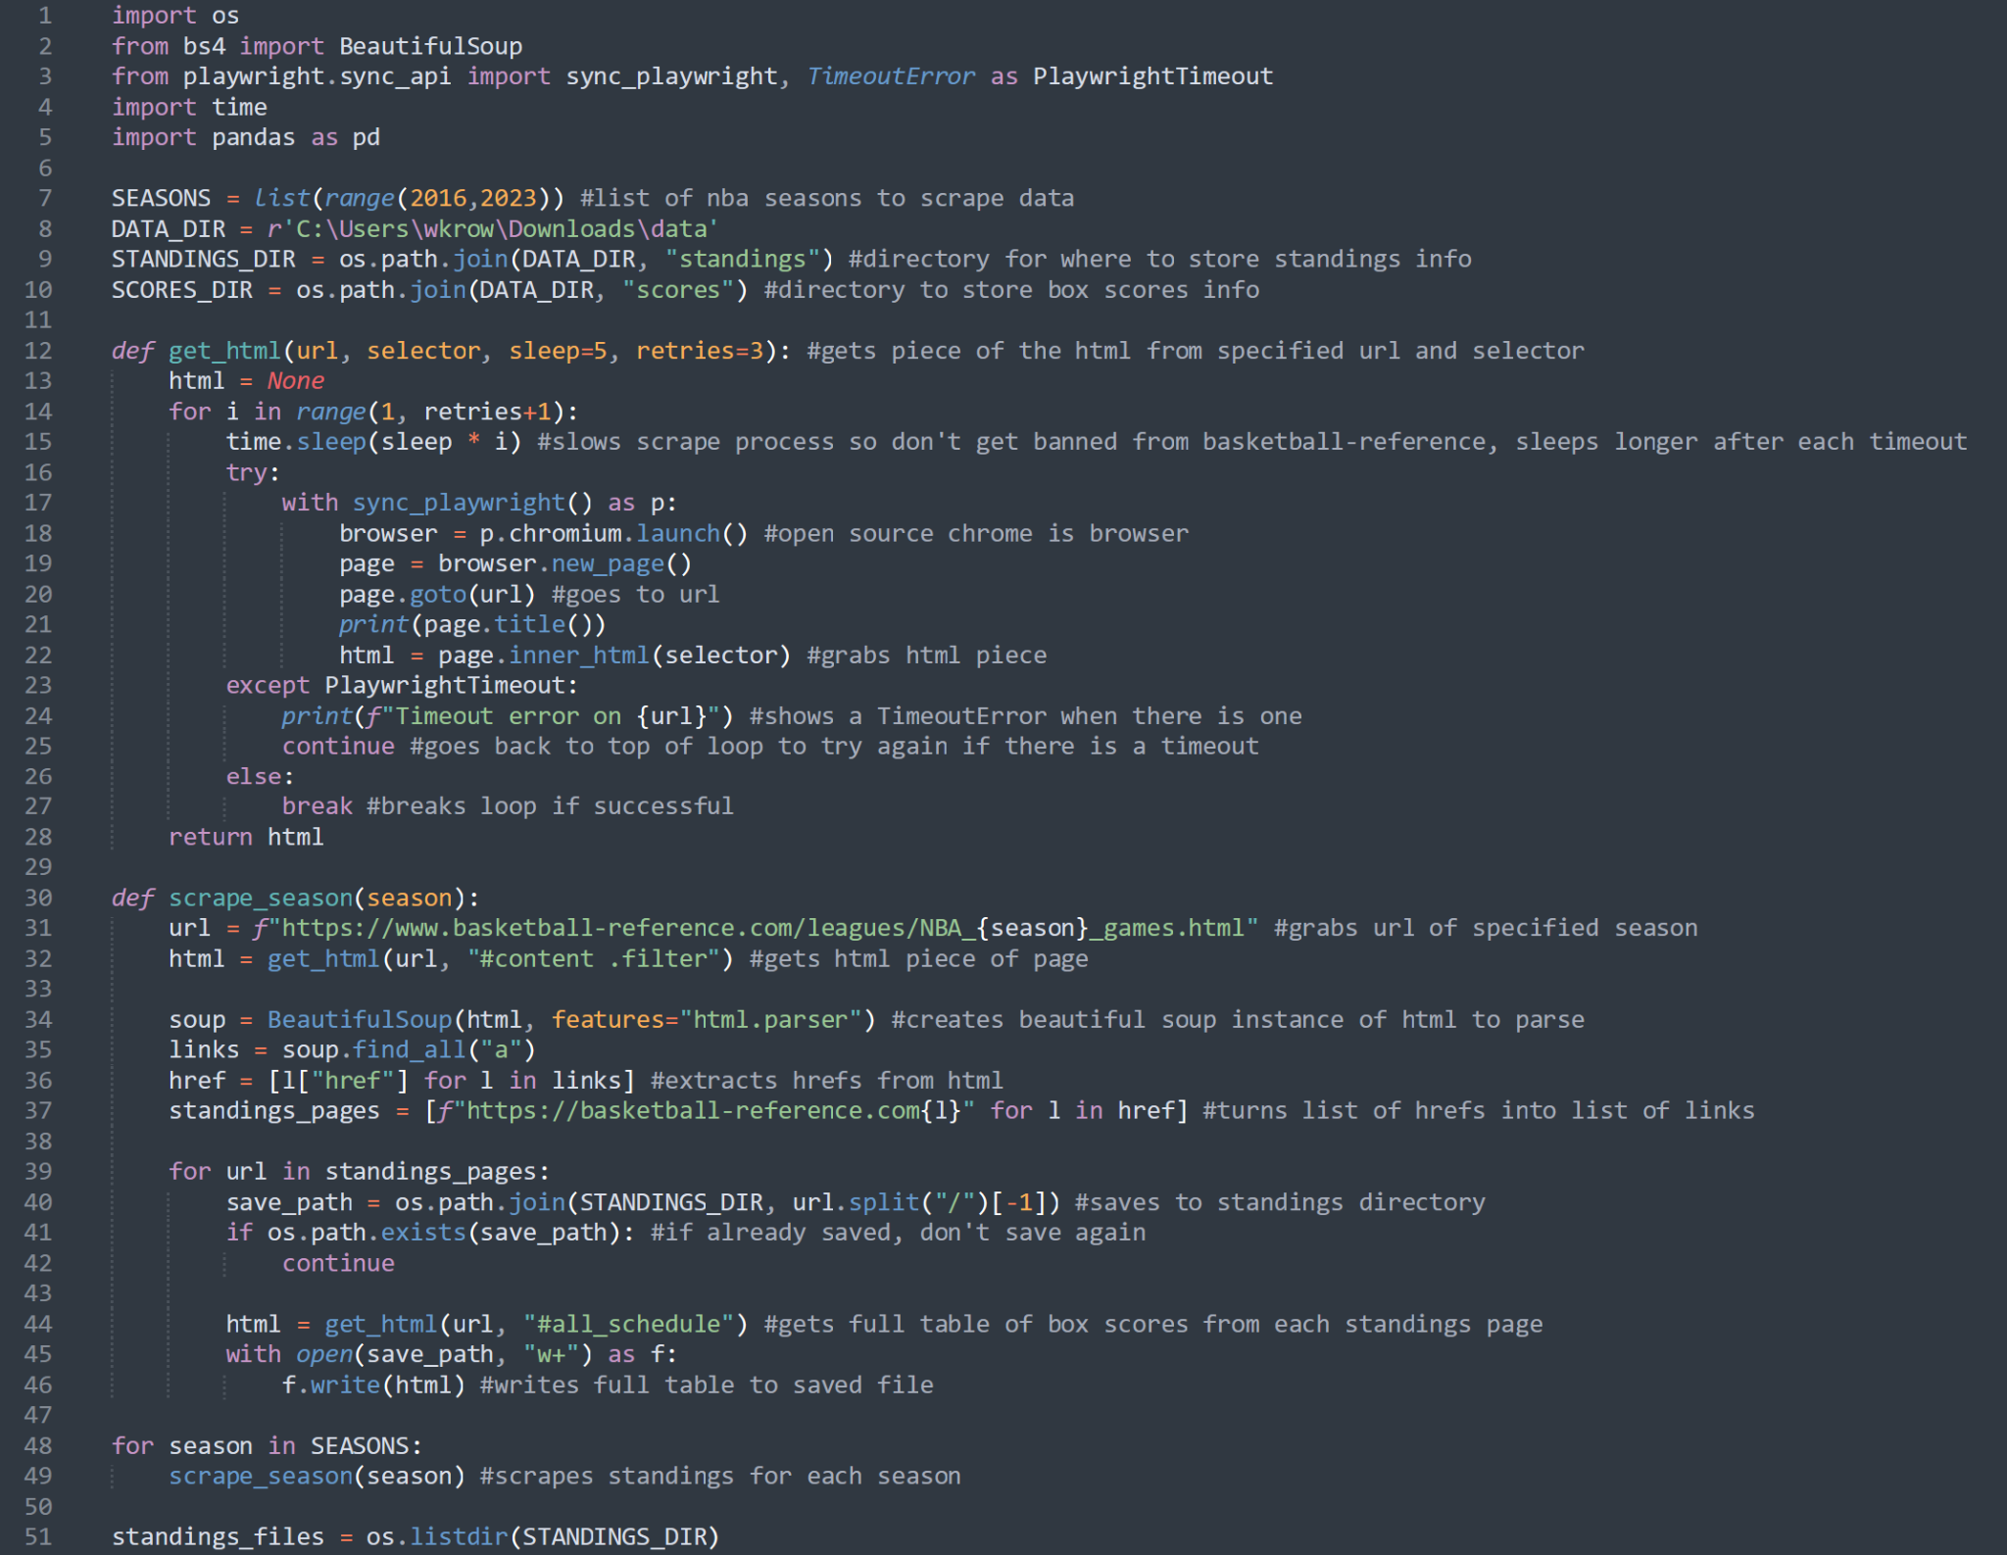

Fig. 8.1

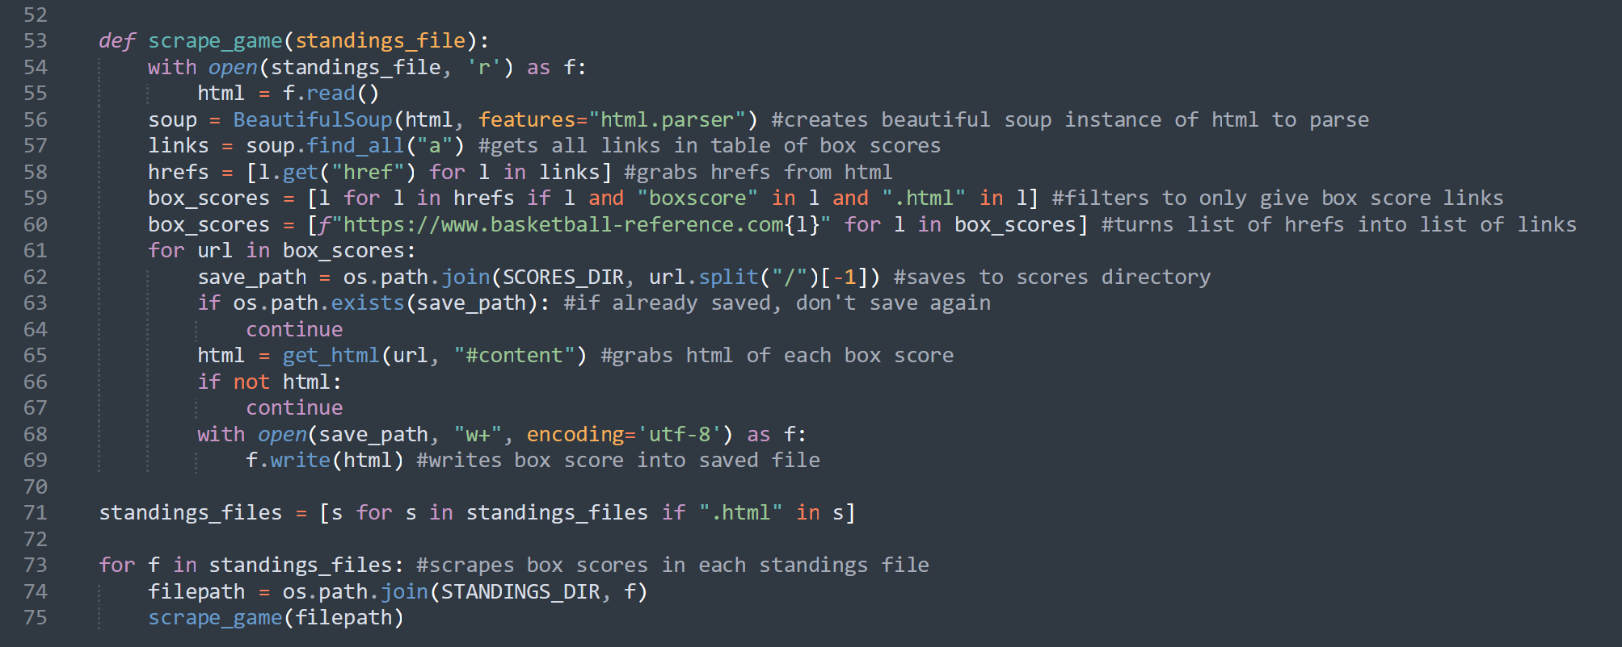

Fig. 8.2

The file parse_data.py, seen in Fig. 9, essentially reads the data from each game’s box score html and turns the data that matters into a clean data frame that can then be analyzed for use. It is important to note that this file also puts each game in the data frame twice, first with a team’s name under the “team” column and the other team’s name under the “team opponent” column and second with the teams’ names and their stats reversed. This will make the data frame analysis easier because when we simulate a team’s games, it will be looking at instances in which their team name is under the “team” column.

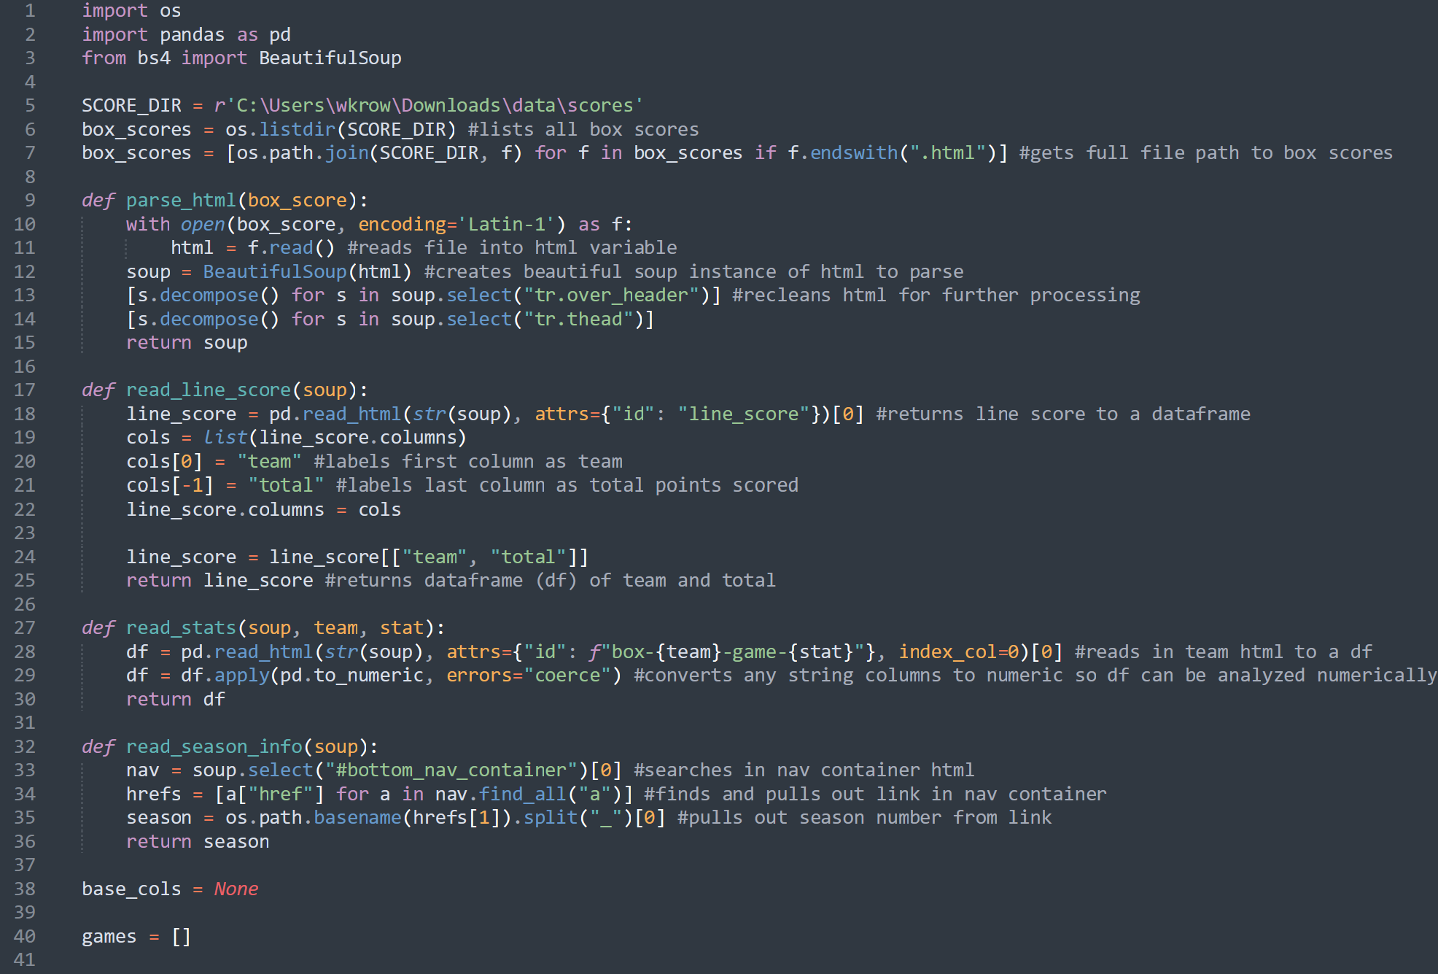

Fig. 9.1

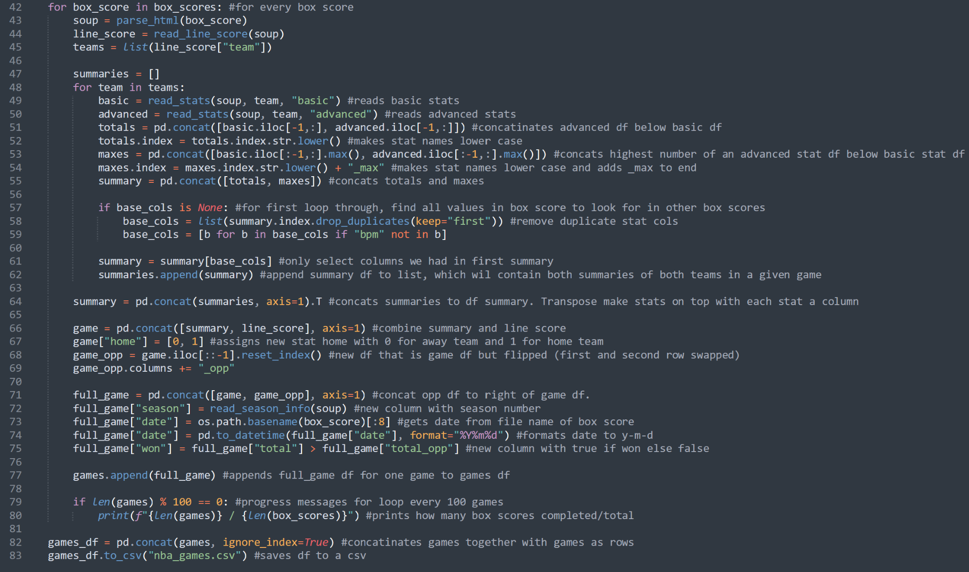

Fig. 9.2

The file test.py (Fig. 10) does all of the rest. This includes machine learning to simulate team win totals during NBA seasons (Fig. 10.2-3), segmenting this into a desired season and taking the sum of wins for that season for each team (Fig. 10.3), printing team info from highest to lowest seeds and plotting simulated versus real team win totals (Fig. 10.5), simulating the play-in bracket (Fig. 10.6), simulating the playoff bracket (Fig. 10.7-9), and displaying the relevant simulated postseason brackets for the selected season as well as the real playoff bracket (Fig. 10.9-10) . Since there are instances of code where it is identical, barring variable names (such as the for loops for east teams and west teams), I will only be showing east instances for each of these sections in Fig. 10 so that the pictures are not too long.

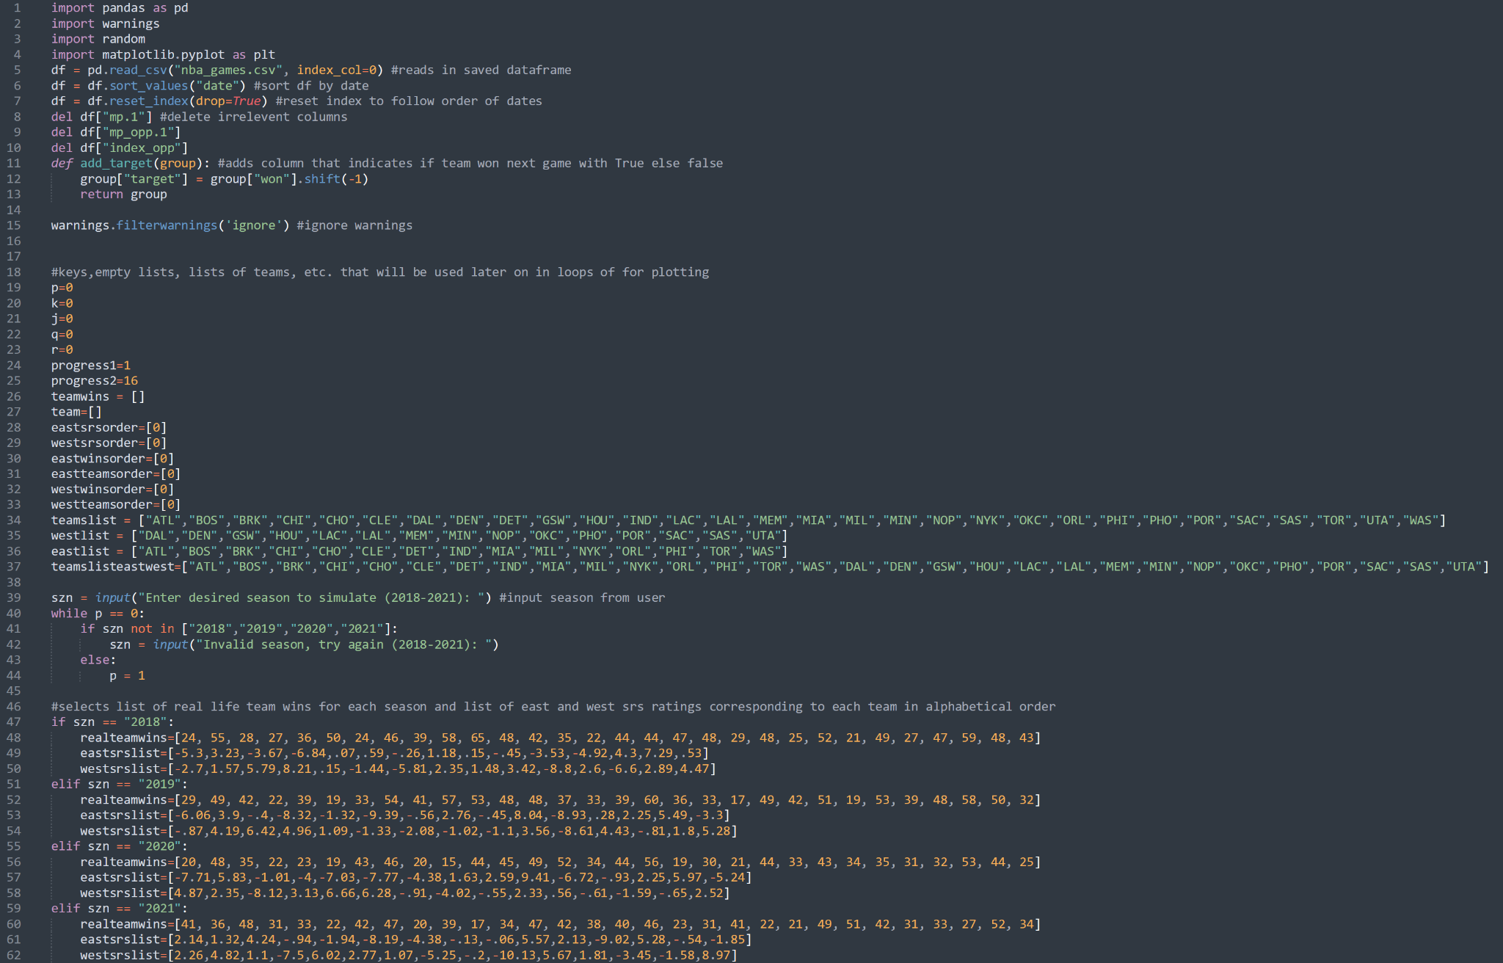

Fig. 10.1

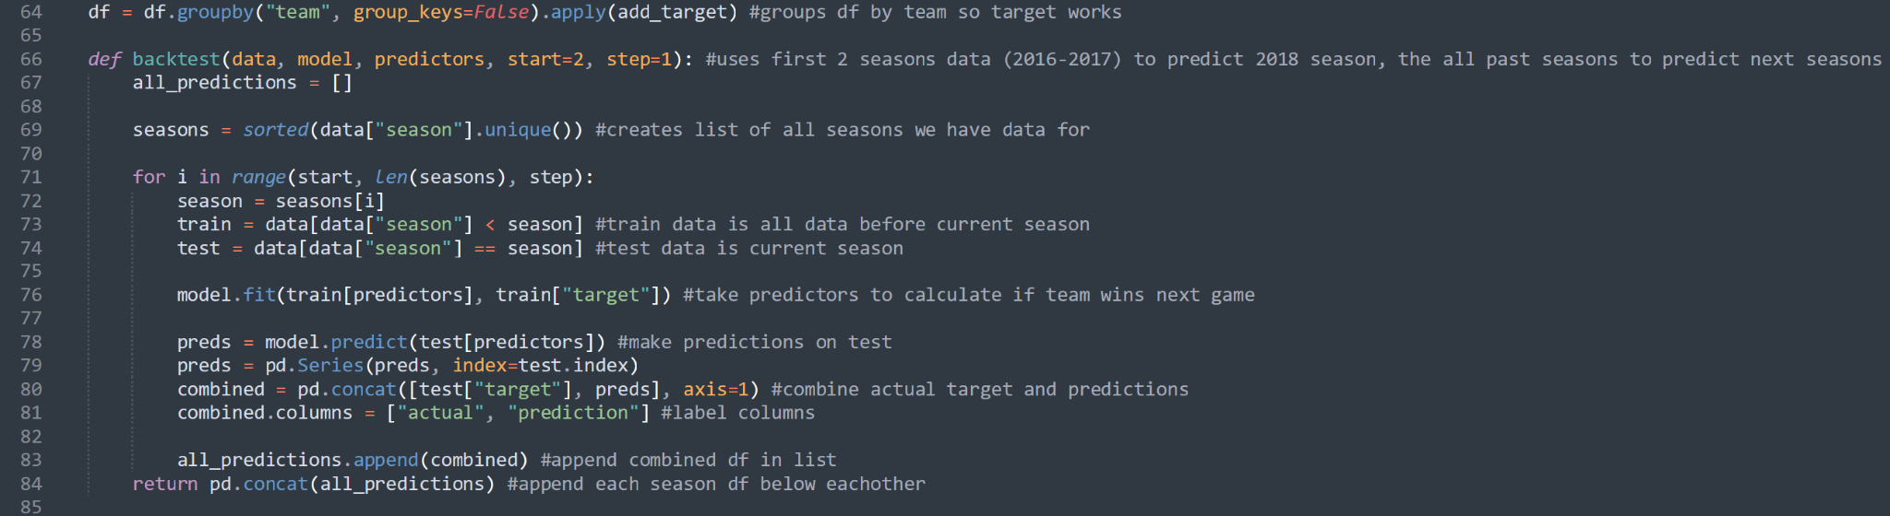

Fig. 10.2

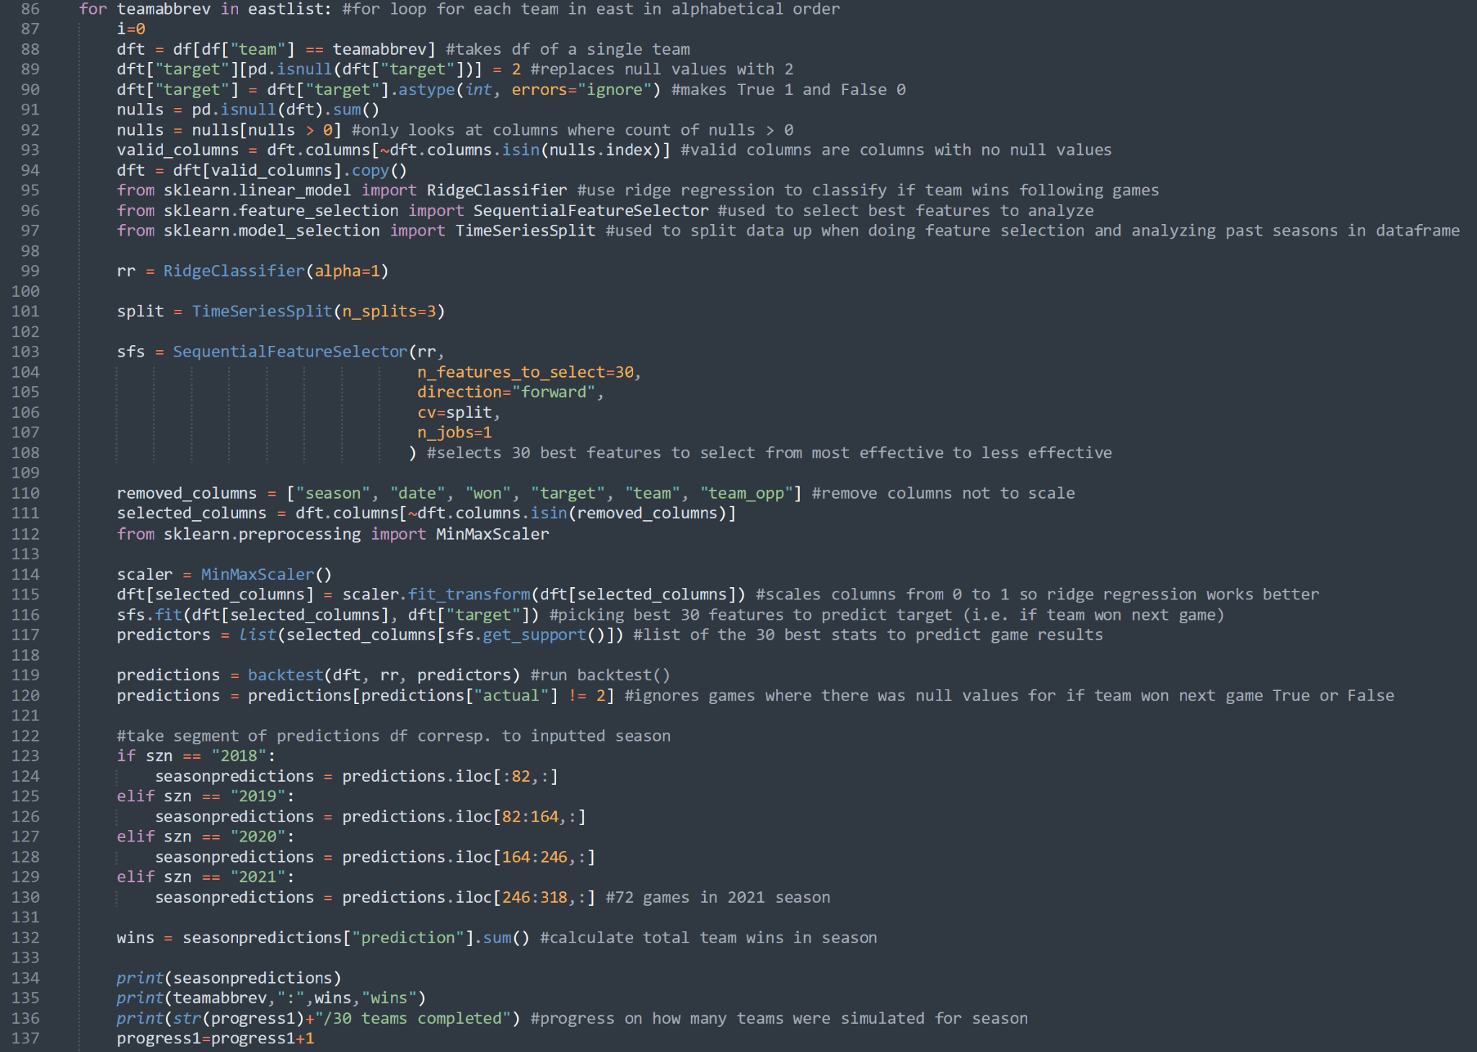

Fig. 10.3

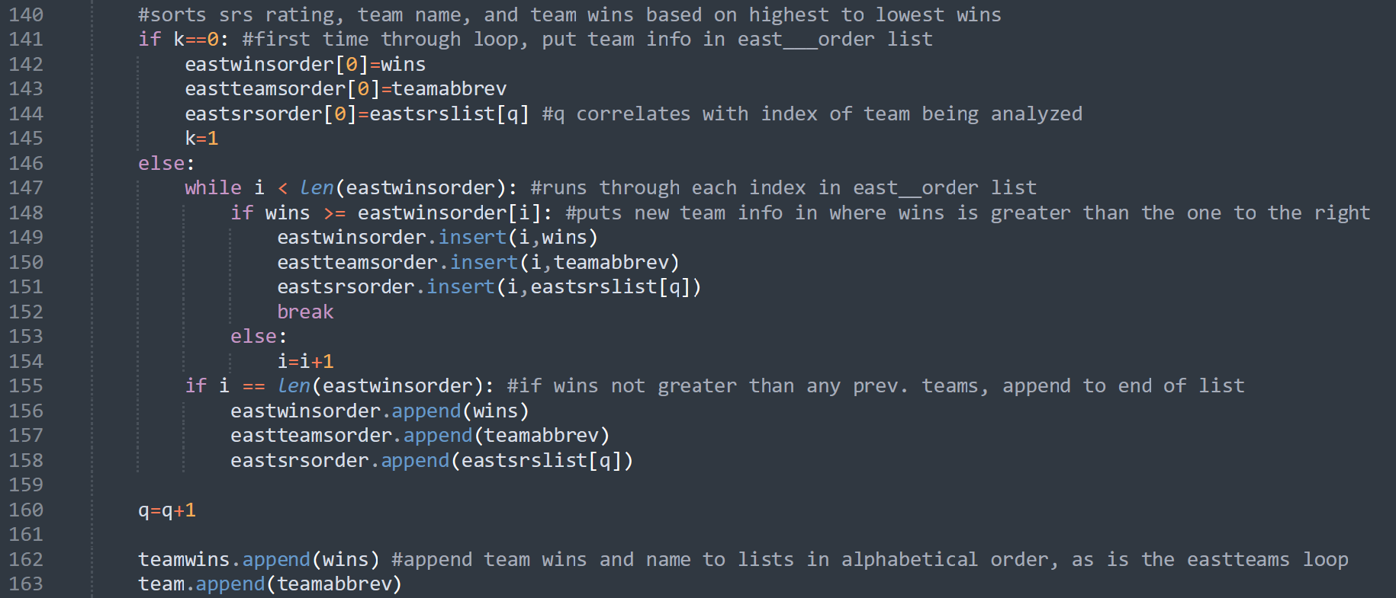

Fig. 10.4

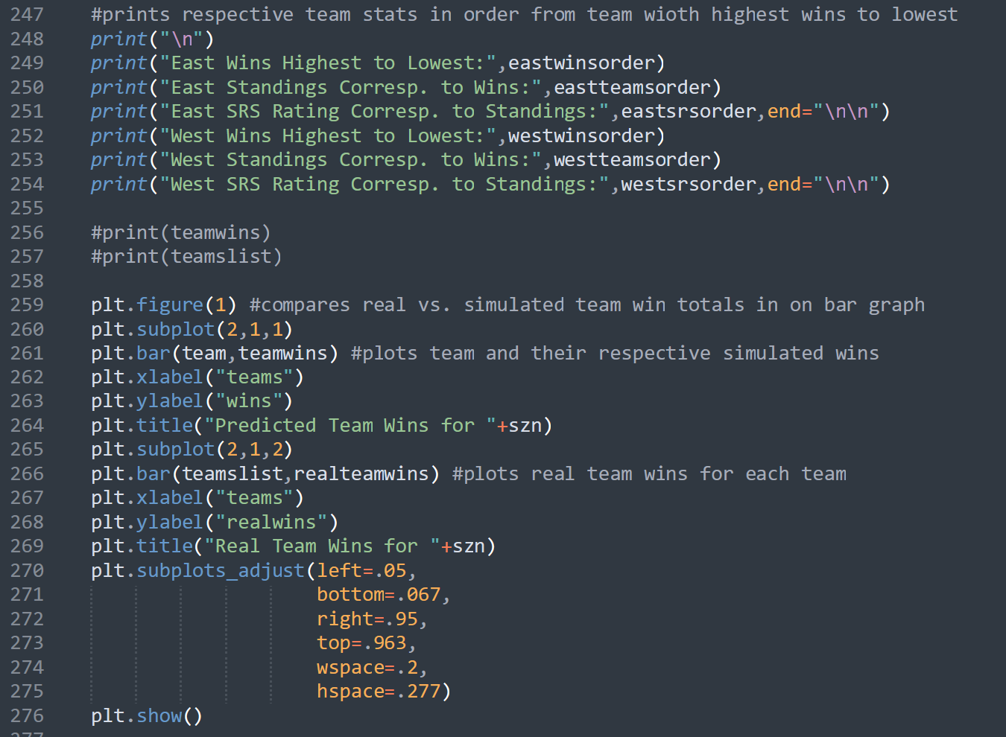

Fig. 10.5

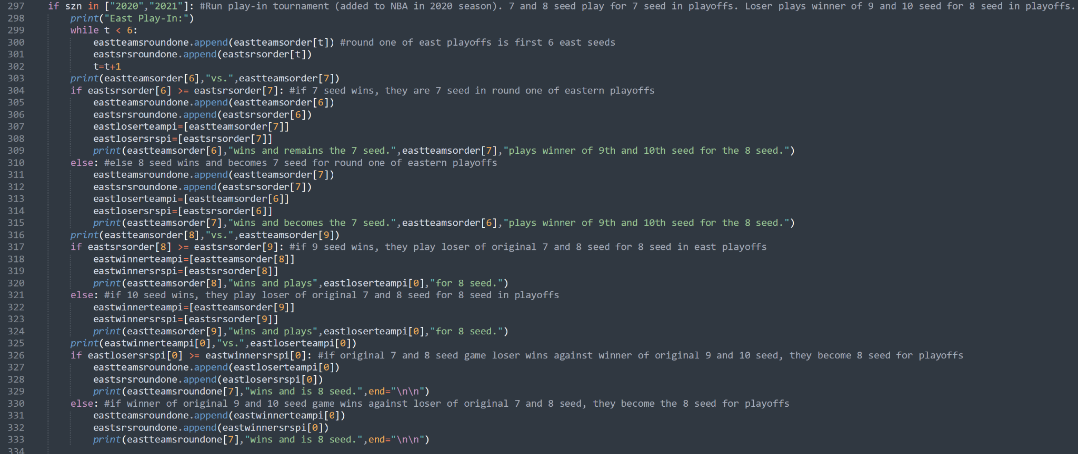

Fig. 10.6

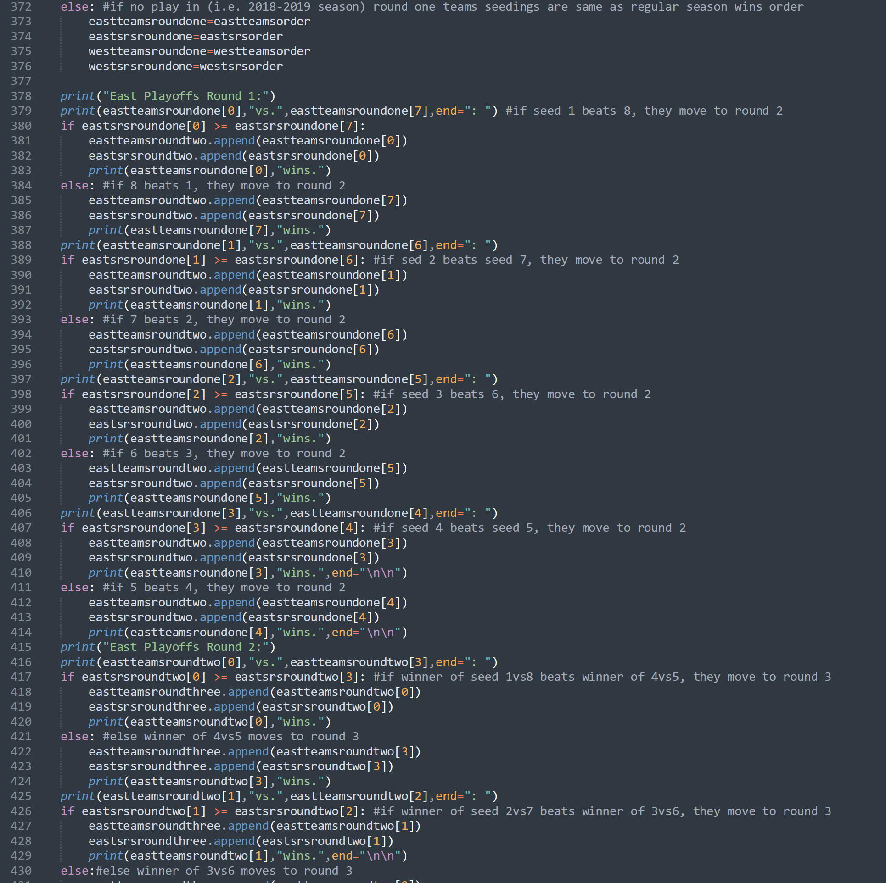

Fig. 10.7

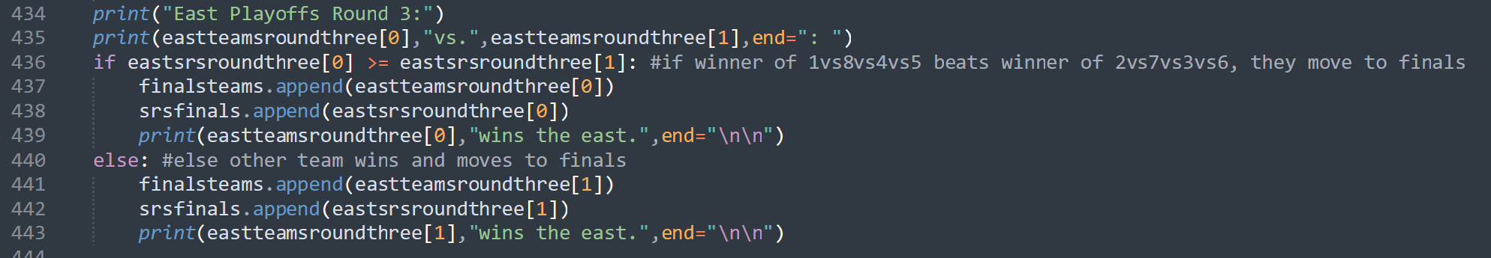

10.8

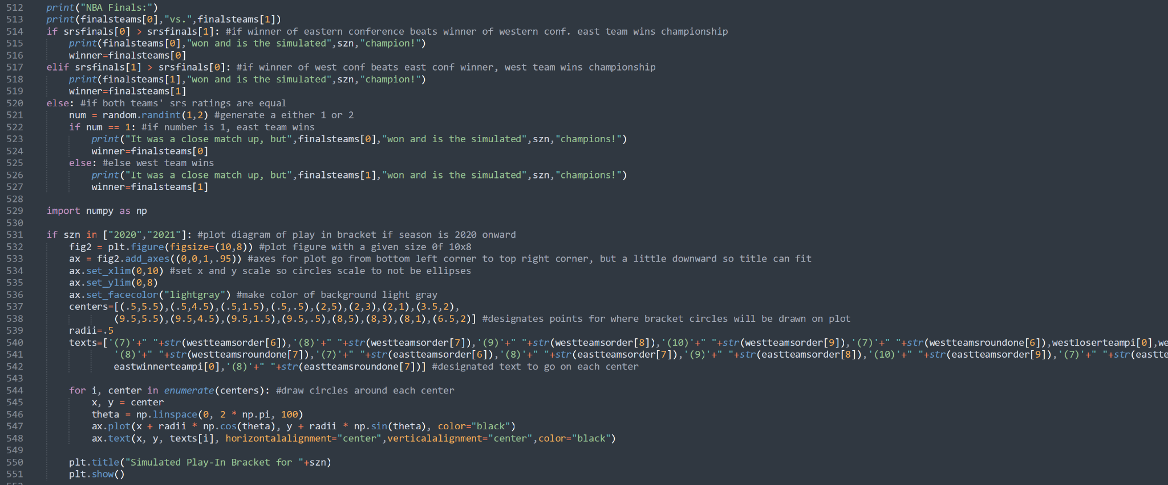

Fig. 10.9

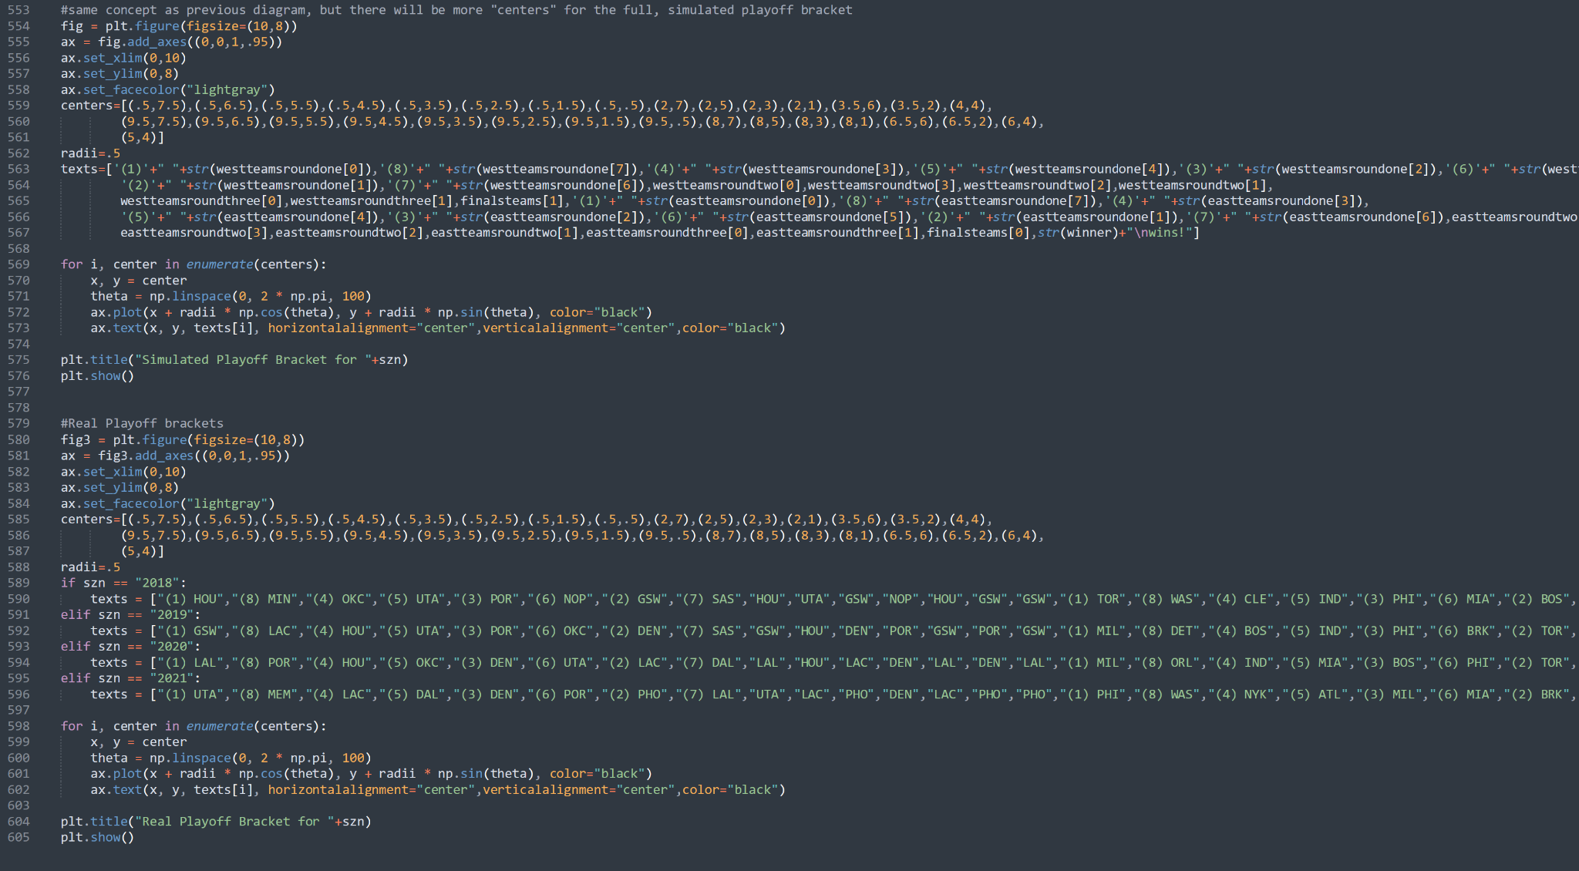

Fig. 10.10

1.4 Concepts Learned/Used

In my project, I utilized many tools, techniques, and concepts which helped me accomplish my goals. From class, I utilized the insertion sort algorithm in order to sort teams’ win totals, names, and SRS all in the same way with the team with the highest wins first in the list to the team with the lowest wins last in the list. This was a good choice as a sorting method because it was easy to embed in the for loop. Because of this, when sorting a team, all previous teams are already sorted, and the analyzed team can be inserted in the list very quickly according to win totals. Additionally, I utilized debugging from class/homework in order to solve many problems I encountered. One instance was in getdata.py when I had code to write box scores into the scores filepath. I was getting a “UnicodeEncodeError” when I tried to run it, and after sufficient research, a skill picked up over time with experience using python, I realized that adding a parameter “encoding=’utf-8’” would fix the problem. The issue was that the box score htmls had characters that were originally not able to be converted into text with the default encoder, but the UTF-8 encoder contains the characters from the html that it recognizes in order to convert the html data into text.

A concept I developed during the project which I implemented was the creation of diagrams using the matplotlib library. Throughout the semester, we focused more on plotting data such as noise on graphs, but I was able to expand my knowledge of this library and create diagrams using the tools it provides in order to visualize the postseason matches and outcomes by using a bracket.

1.5 Retrospective

Looking back on my project, I would have done some things differently. For example, I would have tried to scrape the data with my own code because it actually did not seem too hard to accomplish. Instead, I would have just imported only the parsing and machine learning code. All you have to do with scraping is open the inspect elements page and identify the tag each html link is embedded in. For my project specifically, it would have just been identifying these htmls for the link to each month and then to each game within each month.

Another thing I would have done if I had more time is organize the list of teams and team wins which is used in the plot of actual team win totals to match the order of the simulated team win totals. The simulated win totals are ordered eastern conference teams first in alphabetical order then west teams in alphabetical order. The real win totals plot is organized with all teams in alphabetical order. This is not a big thing, as both charts are still organized where the user can still identify the teams fairly quickly, but it would be even easier if the real win totals chart was organized just as the simulated team wins are.

Additionally, with more time, I would have tried to add arrows to the brackets I generated so that the user could determine how teams transition from the first round, to the second round, to the conference finals (third round), and to the finals and declared winner of the championship. Though as of now it is not difficult to discern which team came from which previous match, it would make users see even more explicitly how this progress occurs.

I think it would have been a good idea to display a logo of the team being analyzed by using OpenCV and also adding the teams’ logos to the bracket diagrams. It would help give the brackets more detail and emulate more of what a professional bracket would look like as well as have the user quickly see the flow of teams through the bracket without having to read the names of each team.

Finally, I would probably have chosen a different subject matter for my project, as there is a lot of data, complications, and non-numerical data that goes into realistically predicting an NBA season. For instance, there can be dramatic trades, transfers of NBA all-stars, injuries, etc. which instantly makes a team go from a one seed one season, to the last seed the following season. These parameters are not necessarily taken into consideration perfectly with the machine learning model. Though this prediction/simulation model does provide a good basis of how teams will perform, team performance is essentially amplified to be worse if the team did mediocre and better if the team did good. This is due to the purely numerical style in which the predictions occur. It assumes an overarching consistency of team performance and roster throughout a season which is not practical for the real world, as context does matter. This can be seen when analyzing the Golden State Warriors (GSW) in the 2020 season. Because the model uses past seasons’ stats to predict the selected season, it assumes they would be a very good team and reach a high win total since they have been for the past several seasons. However, in reality, their team succumbed to many injuries from the start of the season which made them one of the worst teams in the league that year. With all that in mind, however, the project does seem to generally give a good overall insight into how some teams would have performed better than others.

1.6 Final Thoughts

Overall, I found this project to be very interesting and thought provoking by challenging me to think of ways to incorporate knowledge I already know with knowledge I gained from research to help and accomplish the goals I set out to reach with this project. This assignment really opened my eyes to the amount of libraries that are out there and how much potential python and coding in general has to interact with the real world, whether it is something everyday such as tracking/calculating taxes, something very niche such as tracking the motion of satellites, or just something for fun such as a video game.